 | 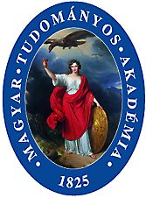 | 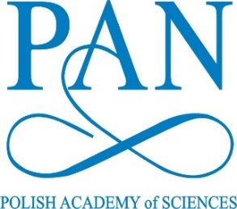 | 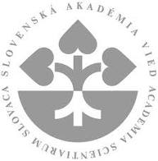

Visegrad Group Academies Forum
Warsaw, Staszic Palace
26-27 September 2017

List of participants

- Czech Academy of Sciences:
- Prof. Eva Zažímalová, President
- Dr Zdenek Havlas, Vice-President for life and chemical sciences
- Prof. Ladislav Kavan, member of the Academy Council responsible
for the CAS participation in ERA
- YRA Laureate: Dr Jiří Schimer

- Hungarian Academy of Sciences:
- Prof. László Lovász, President
- YRA Laureate: Dr Éva Borbély

- Slovak Academy of Sciences:
- Prof. Pavol Šajgalík, President
- Dr Dušan Gálik, Scientific Secretary
- Prof. Peter Samuely, Vice-President for Science, Research and Innovations
- YRA Laureate: Dr Tomáš Smolek

- Polish Academy of Sciences:
- Prof. Jerzy Duszyński – President
- Prof. Paweł Rowiński – Vice-President
- Prof. Stefan Malepszy – Vice-President
- Prof. Elżbieta Frąckowiak – Vice-President
- Prof. Edward Nęcka – Vice-President (tbc)
- Dr Anna Plater-Zyberk – Director, International Cooperation Department
- YRA Laureate: Ms Alicja Kościelny, MSc

- Austrian Academy of Sciences:
- Prof. Anton Zeilinger - President

