A new world record for measuring the mass of a neutrino. Czech scientists also contributed to the success
OR
Neutrino is lighter than previously thought. Czech team contributed to the record-breaking measurement
Scientists from the international KATRIN experiment have determined the tightest direct upper limit of the mass of the neutrino - the most numerous particle that is all around us but escapes normal detection. The new result shows that the neutrino weighs less than 0.45 electron volts, about a million times less than the mass of an electron. A team from the Institute of Nuclear Physics of the Czech Academy of Sciences was also instrumental in the measurements, which were published in the prestigious journal Science.
With this latest release, KATRIN has set a new world record, lowering the mass limit by 0.35 electron volts from the 2022 value of 0.8 electron volts. Behind this milestone is a unique experiment in Karlsruhe, Germany, involving more than 20 research institutions from seven countries.
"This result keeps KATRIN at the forefront of world research in the field of direct neutrino mass measurement. We have now already reached a limit four times tighter than the previous generation of experiments," says Kathrin Valerius from KIT Karlsruhe.
KATRIN uses the beta decay of tritium, an unstable isotope of hydrogen, to determine the neutrino mass. The key contribution of Czech scientists from the Institute of Nuclear Physics of the CAS was the development of a gaseous source of monoenergetic electrons based on the radioactive decay of one of the isotopes of krypton.
“This source is the gold standard for precision energy calibration of the beta spectrum and the only way to determine the correction necessary to determine the neutrino mass,” says Drahoslav Vénos from the Department of Heavy Ion Physics at the Institute of Nuclear Physics of the CAS.
The team from the Nuclear Physics Institute co-founded the KATRIN experiment in 2001. The NPI is also the only scientific institution in the Czech Republic participating in this important experiment.
Ondřej Lebeda, Head of the Department of Radiopharmacy at the Nuclear Physics Institute added: "Years of experience in radionuclide preparation, separation methods and process automation have enabled us to safely prepare a unique krypton source with the desired properties.”

Neutrinos are among the most mysterious particles in the Universe. They are all around us, but they are also extremely difficult to detect. In the Universe, they influence the formation of the large-scale structures of galaxies, while in elementary particle physics their tiny but non-zero mass serves as an indicator of previously unknown physical processes. Accurate measurement of the mass of the neutrino is therefore essential for a complete understanding of the fundamental laws of nature - and also to determine the mass of the entire universe.
The quest to experimentally determine the mass of the neutrino has attracted physicists since the first half of the 20th century. The first experimental measurement was attempted in 1948; at that time the upper limit was set at 5,000 electron volts. A value that is 11,000 times higher than the just published KATRIN result.

Photo captions:

1
KATRIN team from the Nuclear Physics Institute of the CAS. From right Drahoslav Vénos, Ondřej Lebeda, Jan Ráliš, Michal Jouja. In the foreground Radomír Běhal. In the background hot chamber with telemanipulators for work with high radioactivity. Photo: NPI CAS - D. Šebek
2
Fig1-T4on PositionB
Target for the production of the calibration radioisotope rubidium Rb-83, which is produced from natural krypton by irradiation with a proton beam from the TR-24 accelerator at NPI CAS in Řež. Photo: NPI
(see picture for possible description)
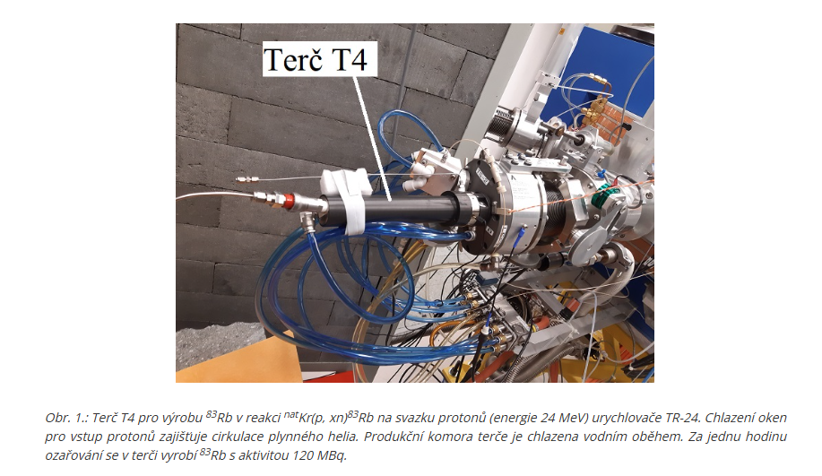

3
TR-24 (1,2)
TR-24 particle accelerator at the Nuclear Physics Institute in Řež. The NPI is, among other things, the largest operator of particle accelerators in the Czech Republic. Photo: NPI

4
47_Mainspec_Eggenstein-Leopoldshafen.jpg
Hard-to-capture neutrinos are measured with a giant spectrometer at KATRIN (photo from the transport of the facility in 2006). The UJF team supplies the Kr-83m emitter generator based on Rb-83 for the measurements. The gaseous Kr-83m is a source of electrons of precisely known energy, which allow to achieve extremely high measurement reliability. Photo: KATRIN
/Explanation of exactly what is happening in the photo: the last stage of the difficult transport of the vacuum vessel of the KATRIN main spectrometer after the previous 8800 km long river and sea journey from the production plant in Deggendorf to KIT (air distance only 220 km).

5
Katrin-logo
Logo of the KATRIN experiment, coordinated by KIT Karlsruhe. Photo: KATRIN

6.
Link to KIT Karlsruhe materials:
/Please notify the media so that photo credits are respected/
https://drive.google.com/drive/folders/1HzHH_O4na0PaYyeFfgze4_lZidxm8Luy?usp=sharing

